PHASE 4 DOCUMENTATION

|  |  |
| --- | --- |
| **Date** | 26-10-2023 |
| **Team ID** | 678 |
| **Project Name** | Personal Blog on IBM Cloud Static WebApps |

# Table of Contents

|  |  |
| --- | --- |
| 1 | Introduction |
| 2 | Problem Statement |
| 3 | HTML Code |
| 4 | CSS Code |
| 5 | Conclusion |

1. **Introduction**

# Static websites are a collection of web pages that are pre-rendered and don't change content based on user interactions. These are typically built using HTML, CSS, and JavaScript, making them lightweight and fast to load. Static websites are perfect for showcasing content, blogs, portfolios, landing pages, and more.

# IBM Cloud Static WebApps simplifies the process of hosting and deploying static websites by providing an easy-to-use platform. It's designed for developers and businesses looking for a reliable and efficient solution without the complexity of traditional web hosting.

# Problem Statement

Create a personal travel blog hosted on IBM Cloud Static Web Apps. Share your travel adventures, tips, and captivating photos with the world. Use IBM Cloud Static Web Apps to easily update your blog and document your journeys. Inspire others to explore the beauty of the world and forge unforgettable memories.

Source code:

3.HTML File

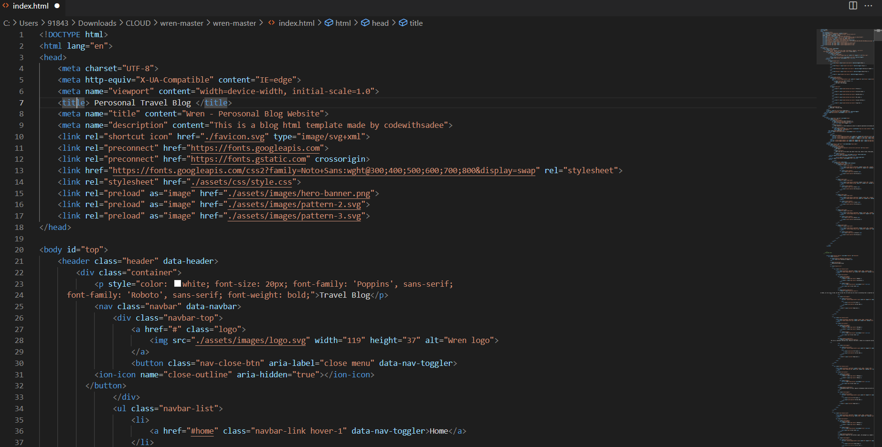

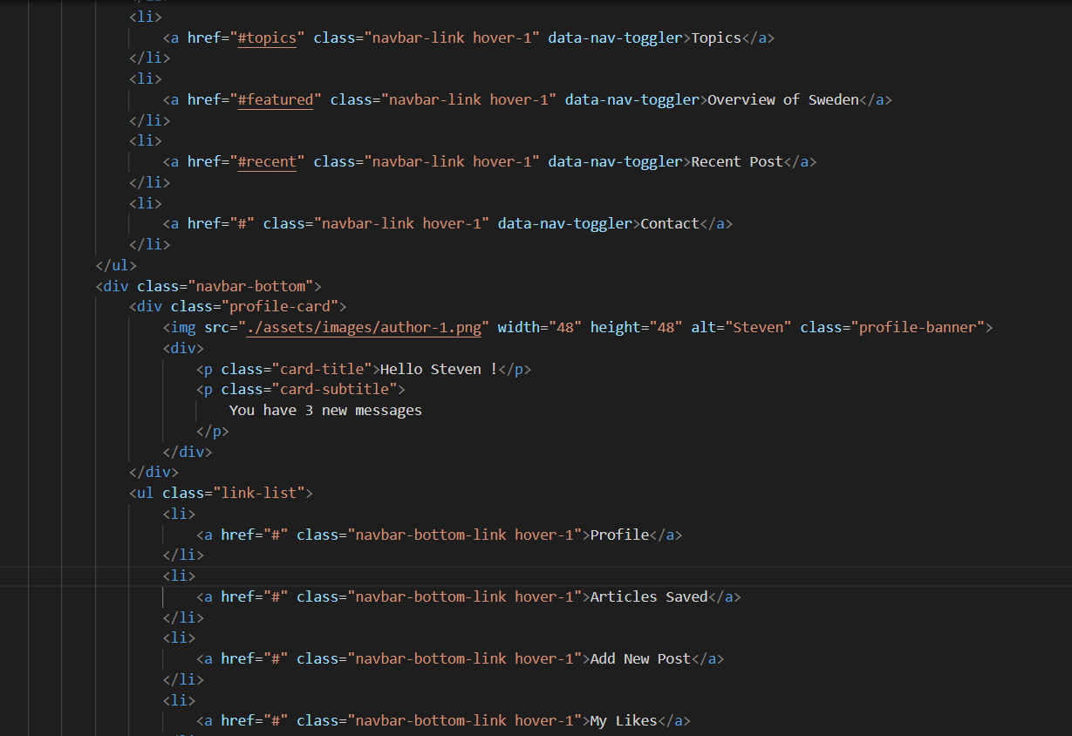

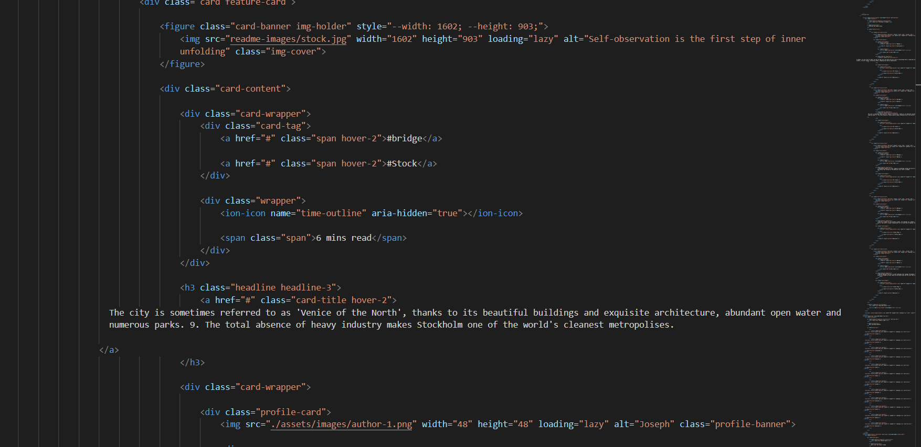

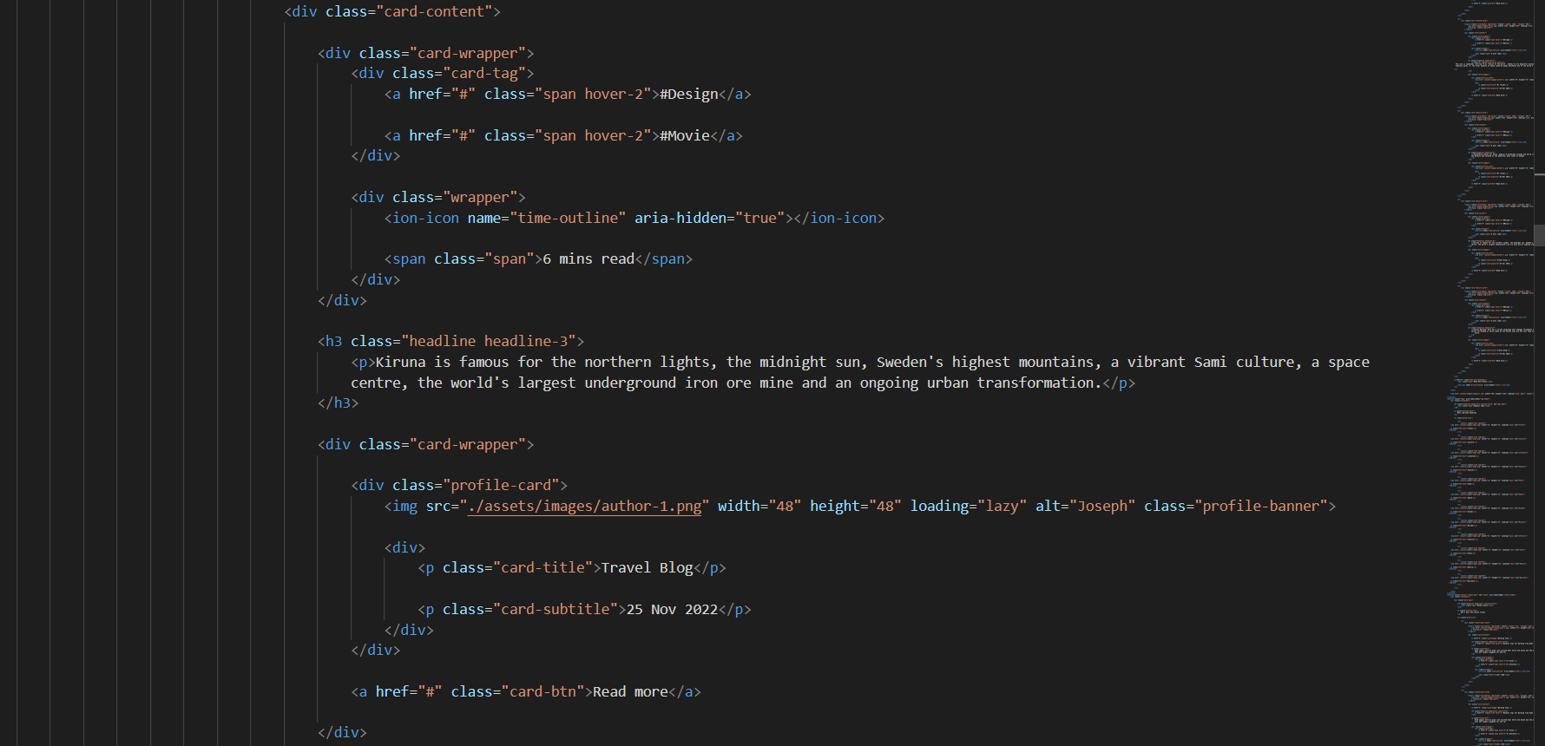

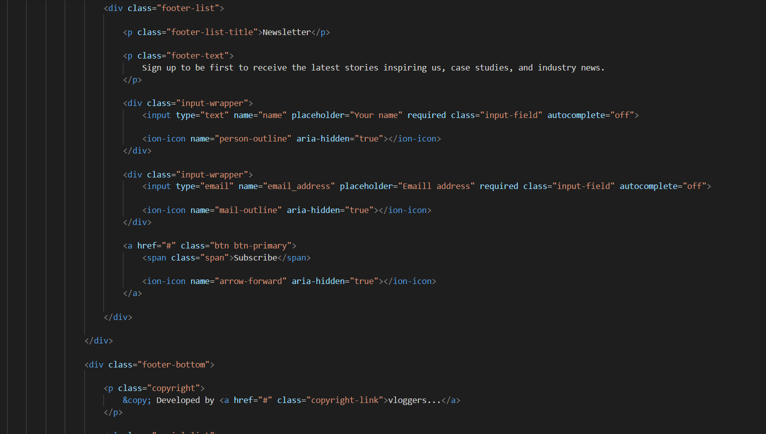

**4.CSS File**

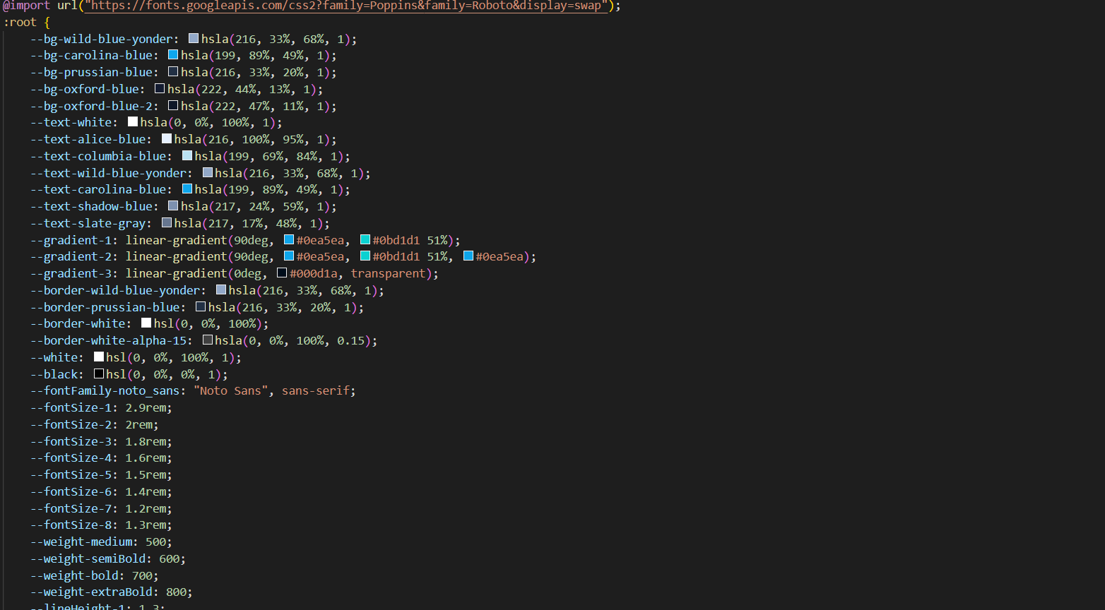

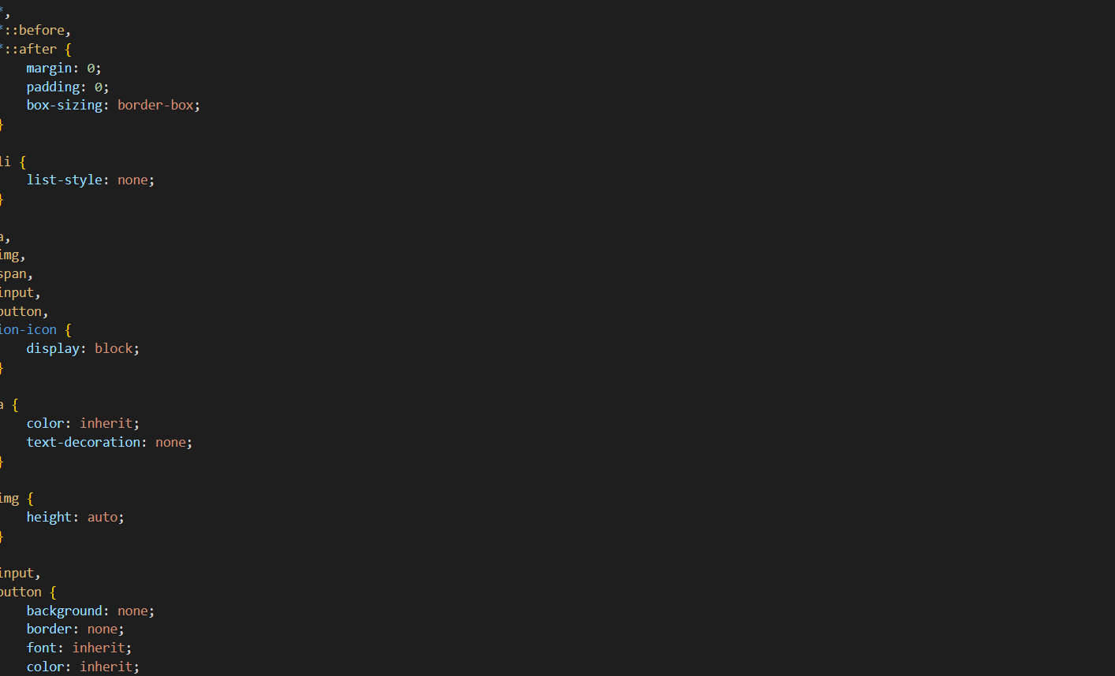

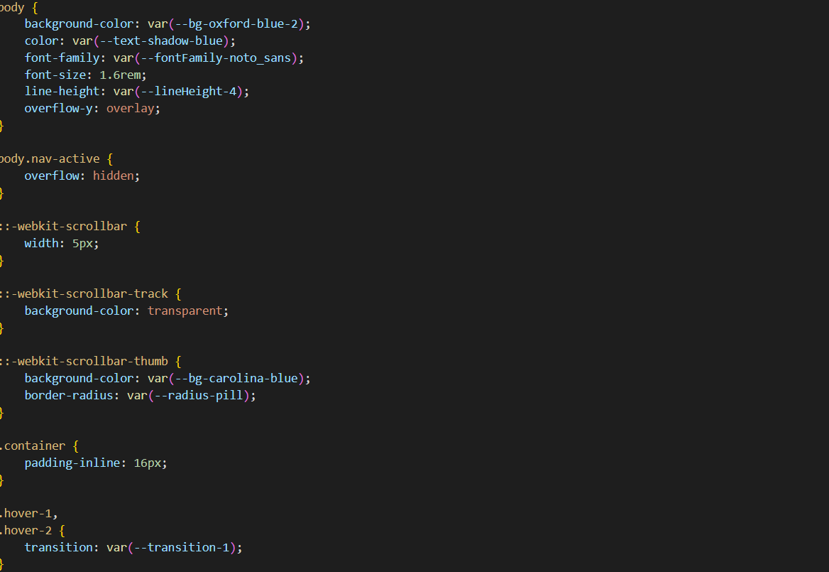

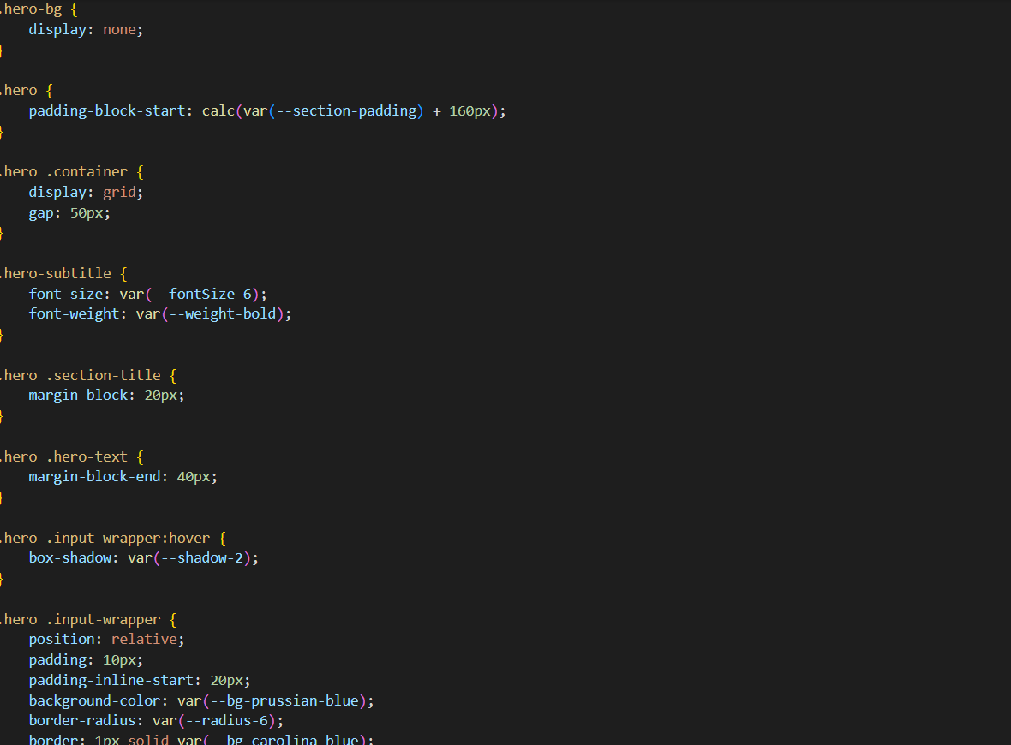

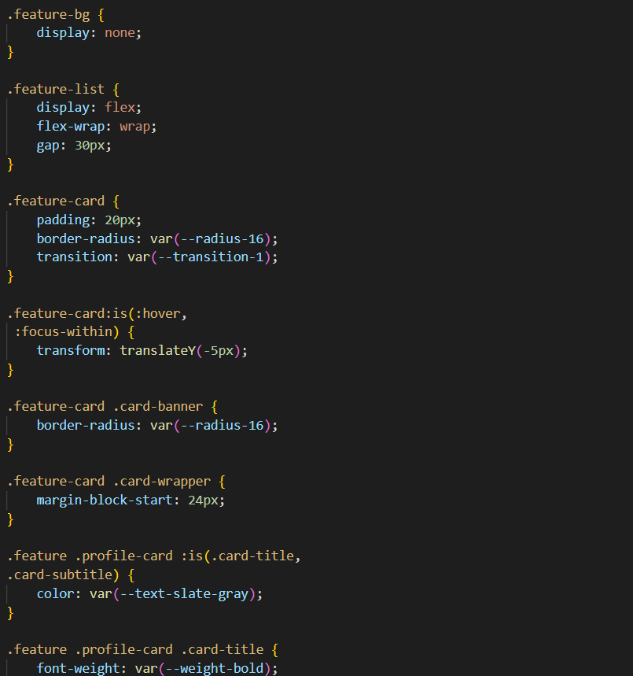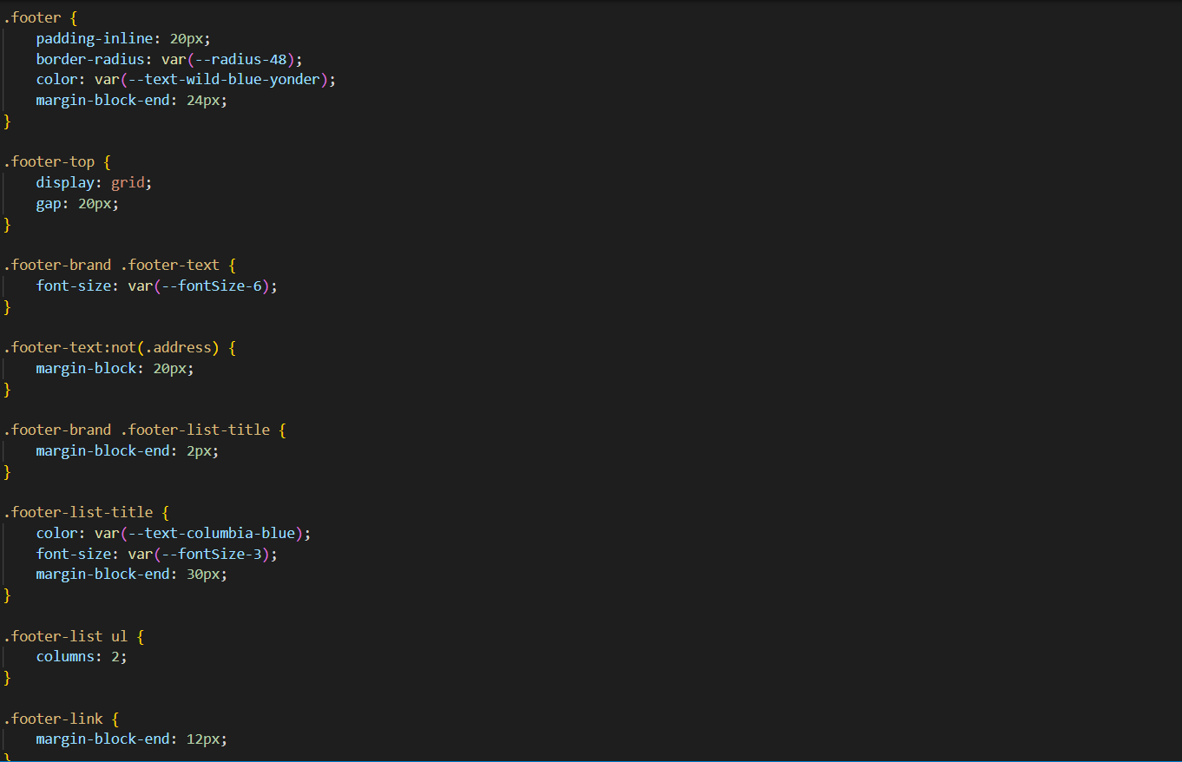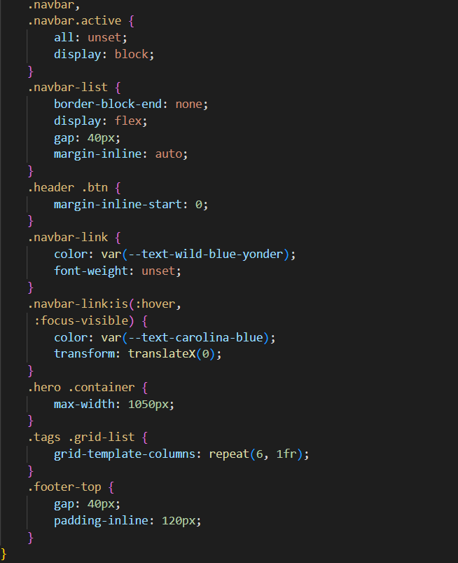

OUTPUT





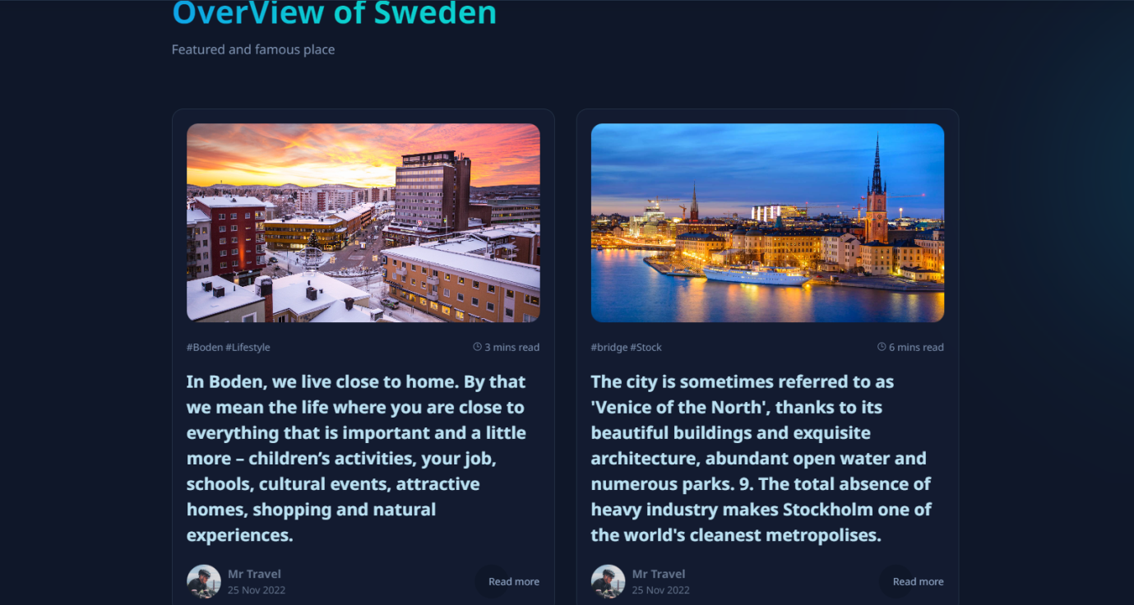

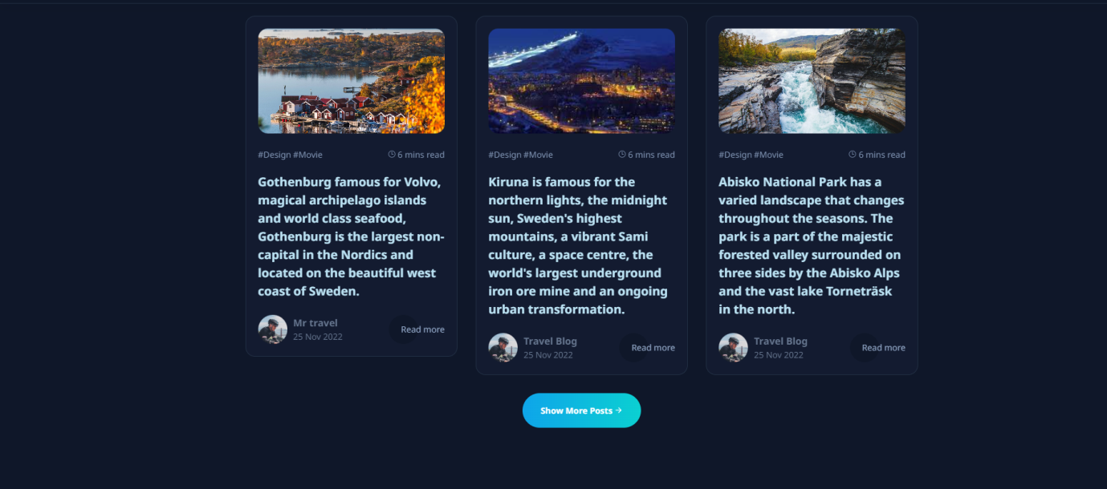







# 5.CONCLUSION:

Hosting your personal blog on IBM Cloud Static WebApps is a wise choice for bloggers looking for a reliable, scalable, and cost-effective hosting solution. It combines the ease of deployment with powerful features to enhance the performance, security, and customization of your blog. By automating deployment, securing your site, and leveraging the cloud's scalability, you can focus on what you do best – creating and sharing valuable content with your audience. With the support of a vibrant community and a wealth of learning opportunities, your blogging journey on this platform can be both productive and enriching.